La tecnología
Word Races

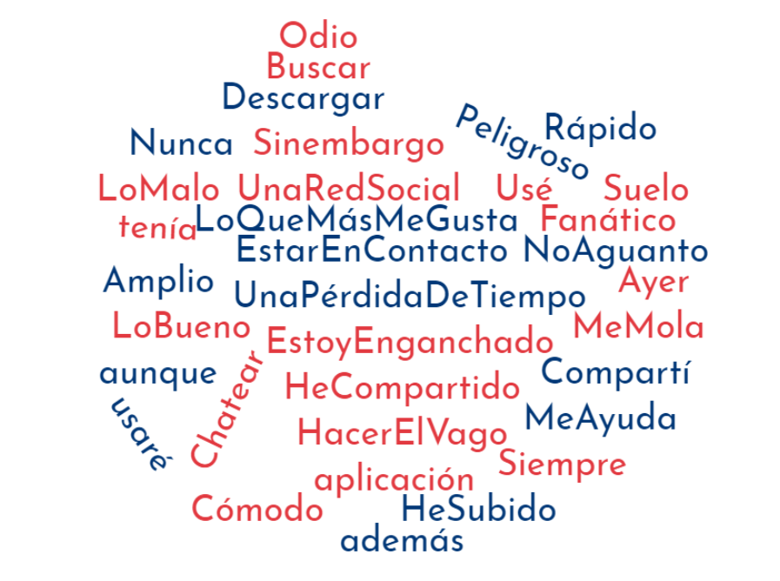
Using the words in the cloud as inspiration write 8 sentences about La Tecnología
- _____________________________________________________________________
- _____________________________________________________________________
- _____________________________________________________________________
- _____________________________________________________________________
- _____________________________________________________________________
- _____________________________________________________________________
- _____________________________________________________________________
- _____________________________________________________________________

